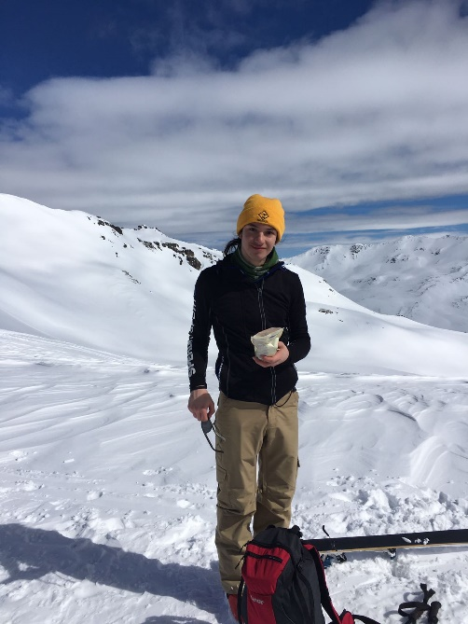
Zeki Ghazoul
Personal details
Address Firth House, Roslin, EH25 9QH, UK
Email zeki.ghazoul@gmail.com
Phone (+44) 75 686 06 931
Date of birth 15.03.2001
Nationality British

Languages
English (mother tongue)
German (bilingual)
Swiss-German (bilingual)
Norwegian (A2 level)

Education
2017-2019 Keswick School, Keswick, UK (6th form)
Physics (B), Maths (D), Geography (D) A-levels
2016-2017 Home Schooling in Zurich for IGCSEs
(IGCSEs completed in 8 months in preparation for Keswick School)
Maths (B), Physics (A*), Chemistry (B), History (B), Geography (B), first language English (B), second language German (A*)
2013-2016 Gymnasium Rämibühl, Zürich, Switzerland
Maths, Physics, Chemistry, Biology, first language German, second language English, second language French, Geography, History, Music, Art, Latin
2012 Trinity Beach State School, Cairns, Australia (6 months)
2007-2013 Primary school Turnerstrasse, Zürich, Switzerland

Qualifications
Full Driving Licence
Teach English as a Foreign Language (TEFL)
Level 5 TEFL qualification
Royal Yachting Association (RYA)
Powerboat level 2 (commercially endorsed)
Competent Crew
Dinghy Instructor
Resuscitation Council (REC)
16 hour First Aid course
Mountain Training Association (MTA)
Rock Climbing Instructor Training
Summer Mountain Leader
British Canoeing (BC)
Open Water Canoe Leader
Open Water Canoe Coach training
Level 2 Raft Guide
Touring Kayak Award
Sea Kayak Leader (tidal) training
Paddle Sports Explore
SUP Module
Core Coach
Foundation Safety and Rescue Training
White Water Safety and Rescue
Coastal Navigation and Tidal Planning
American Association of Snowsports Instructors (PSIA-AASI)
Ski instructor level 1

Interests
Music | Saxophone since 2012, piano since 2006.
Sports | A keen interest in all the sports I instruct or guide.
Cricket | Zürich Crickets Cricket Club (2008-2017), played as wicketkeeper-batsman for Swiss U15 Cricket team. Member of Keswick cricket club during 2018.
Reading | A variety of genres, particularly Sci-fi and Fantasy, as well as non-fiction on current politics.
Experience
2022 Summer season working as an instructor at Ridgway Adventure
2021-22 Winter season training and working as a ski instructor at Active Outdoor Pursuits in Newtonmore
2021 Summer season working as Activity Instructor at Acorn Adventure and Stubbers Adventure Centre
2020-21 Instructor Training Course at Active Outdoor Pursuits in Newtonmore
2020-21 Volunteering part time as trading and development assistant at the Penicuik Storehouse community hub
2020 3 weeks volunteering in Cambodia, teaching English at Hope Agency School
2019 4 weeks volunteering in Tanzania, building schools with Camps International
- 4 months working as waiter in Café/Bar 26 in Keswick
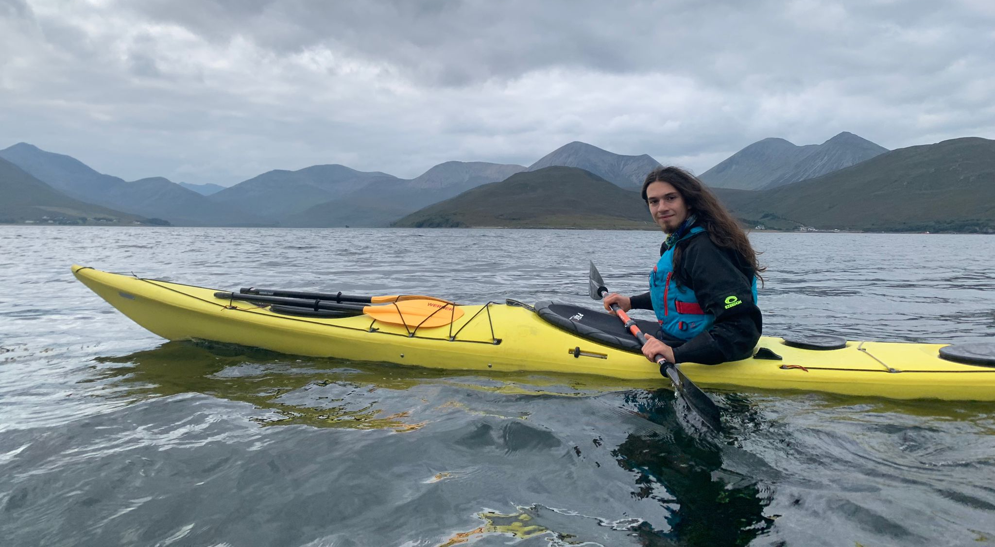
2018-19 1 year tutoring physics and German to year 7-10 school students

